snow & ICE operations Risk Management guidelines
Canadian nursery landscape association
October 18, 2018



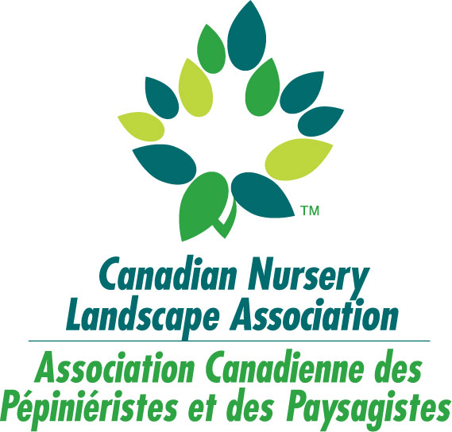
Contents
- Objective 3
- Statement of Conduct, Principles and Ethics 4
- Contributions 6
- Using This Guide 7
- Snow & Ice Operations Risk Management Guidelines 9
- Contracts 10
- Site Preparation / Inspection 14
- Snow & Ice Maintenance On-site 16
- De-Icer / Salt Application Rates 18
- Equipment Calibration 20
- Material Usage Tracking (Smart About Salt Council) 21
- On-Site Snow Storage / Dumping Areas 23
- Off-Site Snow Storage Disposal Sites 24
- Slip & Fall and Property Damage 25
- Bulk Salt Purchasing 27
- Bulk Salt Loading / Storage / Transport 28
- Incident Management 30
- Vehicle Inspection 32
- Vehicle / Equipment Maintenance 33
- Operator Selection Criteria 34
- Driver / Operator / Employee Manual 35
- Driver / Operator Training 36
- Employee Safety Training 38
- Record Keeping & Legal Review 41
- Complaint Handling 42
- Background – “Why Risk Management?” 43
- References 49
- Smart About Salt Council – Example Boxes from Core Accreditation Standards 50
- Sample Forms / Checklists 57
- Sample Daily Winter Log Sheet 58
- Sample Vehicle Accident Report Form 59
- Definitions / Glossary of Terms 60
- Sample Scoring / Assessment Scheme 64

Table of FIgures
Figure 1: Process Map 8
Figure 2: Risk Management Process 44

Objective

This Snow & Ice Operations Risk Management Leading Practices document has been produced by Marsh Risk Consulting to support CNLA and associated provincial association members in the development of risk management programs with respect to snow & ice maintenance operations. The collaborative development process included seeking input on scope and performance aspects of the tool from various CNLA members, and referencing various resources, codes and standards, namely:

- Smart About Salt Council (SASC)
- Snow & Ice Management Association (SIMA)
- Environment Canada (Best Management Practices for Salt Use on Private Roads, Parking Lots & Sidewalks)
- Transportation Association of Canada (Syntheses of Best Practices Road Salt Management)
- Conservation Ontario & Ontario Good Roads Association

The guide provides a process to help facilitate a consistent approach for the management of risks for common snow & ice maintenance operations.

The Leading Practices document is intended to be a simple and practical tool to assist users in effectively identifying, prioritizing, and managing / mitigating potential risks. Applying the outlined process will also serve to broaden the knowledge and understanding of risks. In addition, using a consistent approach will support the sharing of risk management strategies between CNLA members. This guide was designed with a process emphasis, hence is structured to be applicable at any stage of snow & ice maintenance activities. It is also intended to be complementary to current CNLA / Landscape Ontario tools and reference materials that also contribute input to managing risk.

Effective communication with stakeholders, both to solicit and understand their needs, as well as to inform them of evolving issues of interest, is integral to the overall success of the risk management process.

Statement of Conduct, Principles and Ethics

This statement outlines the most important principles of ethical and professional conduct. Members are encouraged and expected to observe these principles in spirit as well as letter.

General Principles
- To serve our clients with integrity, knowledge and creative ability.
- To act fairly, honestly and in a manner they would be prepared to defend publicly.
- To maintain confidence and trust in the profession of snow & ice maintenance.
- To protect, at all times, the integrity of the profession, the interests of the client and the general public.
- To continually improve their own professional knowledge and skill and keep abreast of new developments in their industry.
- To encourage and support education and research within the snow & ice maintenance field.
- To provide other members with helpful, constructive and professional advice, coaching and mentorship when necessary in order to improve the professional reputation and image of the industry.
- To consistently maintain the confidence and trust in the profession.

Operating Principles
- Members have an obligation to deliver goods and services in an efficient and cost-effective manner, (subject to the specifications of their contracts) in order to protect the client’s interest while maintaining acceptable standards.
- Members advertising shall be neither false nor in any way misleading.
- Members shall respect and minimize their impacts on the environment.
- Members shall treat employees fairly, honestly and lawfully.
- Members shall not make false or malicious statements that may injure the professional reputation of other members.
- Members shall endeavour to attract to the profession, individuals with a high degree of honesty, courtesy, integrity and competence
- Members shall meet their obligations and responsibilities to clients, suppliers and employees.

Contributions

Canadian Nursery Landscape Association, Landscape Ontario and Marsh Risk Consulting would like to recognize the following organizations and individuals for their valuable time and professional input throughout the development of this Snow & Ice Operations Risk Management Guide.

Snow & Ice Management Committee, Landscape Ontario

Jon Agg, Pristine Property Maintenance
Gerald Boot, Boots Landscaping
Megan Campbell, Marsh Canada
Lee Gould, Smart About Salt Council
Eric Hodgins, Region of Waterloo
Mark Humphries, Humphries Landscape Services
Robert Kennaly, Kennaly Construction Law
Jim Monk, Markham Property Services Limited
Luke Pallister, Marsh Risk Consulting
Brian Perras, BP Landscaping
Jamie Perras, BP Landscaping
Robert Roszell, Tuff Tech Bags
Terry Nicholson, Clintar

Using This Guide

This guide is organised to provide the user a baseline grounding in risk management, and to provide a working tool that will directly facilitate an effective risk management process for CNLA member companies.

The Guide is structured to identify and address risks along the snow & ice maintenance continuum. For each element of the process, the following is included:

        - The ‘Risk Context’. – A synopsis of the subject area from a risk context

        - Potential Risk Issues. – A listing of the potential risks associated with the activity

        - Risk Management Leading Practices. – As part of an overall risk control system, a series of performance based risk management and control program elements that suggest leading practices to address the risk issues and underlying causes of loss or failure.

        - ‘Rating’ - A column to use as a self-assessment to help CNLA members compare their current programs for each risk issue against the listed leading practices. This can help provide a framework for future improvement by identifying and prioritizing opportunities to improve risk control programs. Members may wish to develop their own assessment or scoring scheme. A sample approach and associated scoring regime is provided in Appendix F.

Figure 1: Process Map

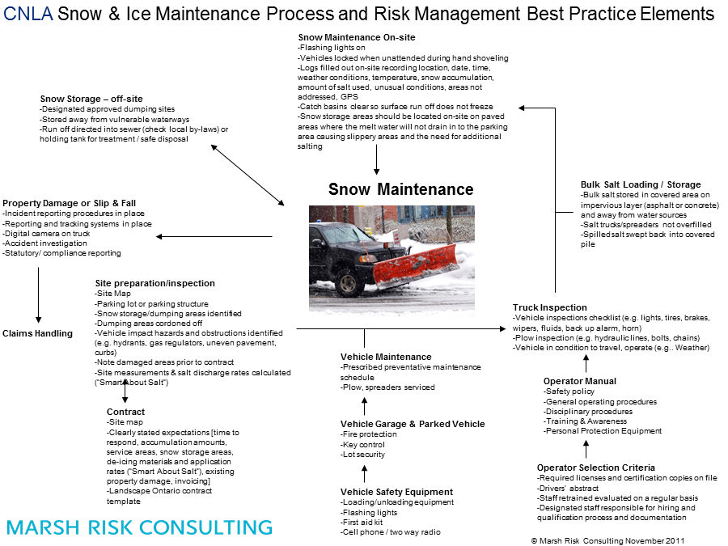

Snow & Ice Operations Risk Management Guidelines

This section expands on the process and risk elements in Figure 1 and provides the framework for leading practices with respect to key risk issues within the snow & ice maintenance industry.

Contracts

Context | Risk Management Leading Practice | Rating
Contracts allocate risk. Written contracts are required to address the various contractual arrangements amongst customers, third party contractors and service providers. Detailed and comprehensive contracts which have been reviewed by legal counsel aid in reducing exposure to litigation claims. Good contracts are also a critical tool to manage client expectations, confirm responsibilities, document pre-existing conditions, and outline payment and record keeping requirements. Standard from contracts might also assist parties to adopt standardized and industry recognized approaches to risk management. | - Contract includes clearly defined scope of work and expectations such as:  - Term of contract  - Start & finish date  - Contract price and payment provisions  - Changes in the work provisions  - Notice Provisions  - Clauses that determine who is to make the call as to when, and in what amounts, ice melting products are to be applied  - Insurance provisions  - Damage waivers  - Reasonable hold-harmless or indemnification provisions that are not over-reaching  - Termination and default provisions  - Maintenance triggers  - Snow / ice accumulations  - Time to respond  - Response times  - Service areas  - Snow & ice maintenance around parked vehicles  - Snow storage areas  - De-icing materials  - Record keeping requirements²  - Responsibilities of on-site staff / monitoring  - Contract includes site map and identifies:  - Areas to be serviced, such as:  - Priority service areas  - Walkways  - Entrances / exits  - Accessible parking stalls / ramps  - Loading zones  - Secondary service areas  - Speed bumps  - Areas not to be serviced  - Areas that can be closed off (areas of low traffic, that have poor surface quality or any area agreed upon with the client and contractor)  - Snow storage and stacking areas identified and calculated¹  - Areas vulnerable (e.g. features and/or plants) to de-icing materials  - Vehicle impact hazards (e.g. hydrants, curbs, phone boxes, light posts, islands, shopping cart stations, etc.)  - areas where ice may build or snow may accumulate based on previous winter maintenance observations at site  - snow fences  - Items of concern  - existing property damage (e.g. potholes, cracked curbs, uneven sidewalks)  - areas with poor drainage / ponding issues  - downspouts discharging onto walkways  - building doors opening into prevailing winds  - lawn sprinkler heads  - Contract includes verbiage that liability cannot be assumed for unforeseen property damage such as:  - catch basins  - speed bumps  - water box valves  - manholes  - lawn sprinkler heads  - Contract includes verbiage that informs client that liability cannot be assumed for slip, trip and fall incidents in areas where hazards have been previously identified (e.g. areas with poor drainage, ponding, downspouts discharging onto walkways, uneven surfaces, etc.  - Contract includes requirement for property owner / management company to provide all available documents and records, including any surveillance camera footage, in the event of a slip, trip and fall incident / claim.  - Signage provided on large snow piles stating “Danger – Do Not Enter” or similar.  - Invoicing
Potential Risk Issues:
Risk areas that contractors should avoid and manage with contracts include the following:

- Scopes of work that are unclear;
- Scopes of work that make unreasonable promises or promise the impossible (such as keeping a premises free of snow and ice at all times);
- Scopes of work that do not clearly set out who decides when, where and in what quantities ice melting products are to be placed
- Contracts that do not address the potential for salt shortages
- Indemnification clauses which are unclear or which offer indemnification where the contractor is neither in breach of contract or negligent
- Indemnification clauses that indemnify for economic losses or beyond the limits of the contactor’s insurance
- Contracts that do not include notice provisions and procedures to be followed in the event of a slip and fall
Notes

1. See Appendix C for Smart About Salt Council – Calculation of Potential Snow Storage Area example (Box 1).

2. See Section “Snow & Ice Maintenance On-site”

Site Preparation / Inspection

Context | Risk Management Leading Practice | Rating
In order to ensure that scope of work is clearly defined, existing hazards are identified, and expectations are adequately managed, it is essential that site inspections are performed prior the contract term and communicated to the client. | - Site map prepared with client and included in contract.  - Contract includes site map and identifies:  - Areas to be serviced, such as:  - Priority service areas  - Walkways  - Entrances / exits  - Accessible parking stalls / ramps  - Loading zones  - Secondary service areas  - Speed bumps  - Areas not to be serviced  - Areas that can be closed off (areas of low traffic, that have poor surface quality or any area agreed upon with the client and contractor)  - Snow storage and stacking areas identified and calculated¹  - Areas vulnerable (e.g. features and/or plants) to de-icing materials  - Vehicle impact hazards (e.g. hydrants, curbs, phone boxes, light posts, islands, shopping cart stations, etc.)  - areas where ice may build or snow may accumulate based on previous winter maintenance observations at site  - snow fences  - Items of concern  - existing property damage (e.g. potholes, cracked curbs, uneven sidewalks)  - areas with poor drainage / ponding issues  - downspouts discharging onto walkways  - building doors opening into prevailing winds  - lawn sprinkler heads  - Site measurements & salt / de-icer discharge rates calculated²  - Damaged areas identified and catalogued prior to contract  - Site visited on rainy day prior to the winter season so that areas of ponding are identified and communicated to client.  - Downspouts discharging onto walkways / serviced areas are identified / addressed prior to winter season.
Potential Risk Issues:
        - Lack of site preparation / inspection results in debate over responsibility of exiting hazards / deficiencies.

Notes

1. See Appendix C for Smart About Salt Council – Calculation of Potential Snow Storage Area example (Box 1).

2. See Sections “De-Icer / Salt – Application Rates” and “Material Usage Tracking”

Snow & Ice Maintenance On-site

Context | Risk Management Leading Practice | Rating
Snow & Ice Maintenance On-Site is the stage of the Snow & Ice Maintenance Operations process most vulnerable to incidents and claims. Standard operating procedures including safe work practices and adequate record-keeping will ensure that the likelihood of incidents on site is reduced and proper documentation is in place in the event of an incident / claim. | - Vehicle warning lights on (hazards lights, roof top beacon, strobes, etc.)  - Vehicles locked when unattended (e.g. during hand shovelling)  - Logs completed before departing site recording*:  - location  - time (start / finish)  - date  - extent of work (services performed)  - pavement condition  - weather observations (type, amount)  - temperature  - type and amount of material (e.g. de-icer, sand) used  - GPS on all vehicles / equipment / personnel¹  - Cameras provided on vehicles  - Catch basins clear so surface run off does not freeze  - Snow stored in areas where adequate drainage is provided thereby reducing the amount of surface run-off draining into parking / walking areas resulting in ice formation creating slippery areas and the need for additional salting.  - Plow / shovel, brush, etc. new snow accumulations prior to any de-icing application (i.e. avoid burning off 2 inches / 5 cm of fresh snow)  - Prevent snow & ice from bonding to driving and walking surfaces. Prioritize anti-icing techniques as a standard practice. (SIMA)  - Spot treat problem areas (e.g. north facing areas) (SIMA)  - Keep salt covered (i.e. tarps, lids, covers) to protect from moisture and potential spillage during applications (sidewalks, lots, roads, etc.), loading, and during transport between sites. (SIMA)  - Snow fences in place as required (maintained)
Potential Risk Issues:
        - Lack of safe work practices results in incident
        - Lack of documentation / snow logs results in increased liability exposure in the event of a claim.
Notes

1. GPS should not completely replace manual record keeping. For instance, hand shovelling should be recorded.

De-Icer / Salt Application Rates

Context | Risk Management Leading Practice | Rating
Application rates vary significantly from site to site depending on several factors including, but not limited to, rate of application (high, medium, low), level of service, surface temperatures, traffic volume & speed, surface conditions, type of material, weather forecast, and type of precipitation. In order to illustrate due diligence and to provide “science” behind the decision to apply material at a predetermined rate, it is essential that application rates be developed in advance of the winter season so that staff are properly trained on which rate to apply. Tracking the rate applied and documenting deviations from the predetermined rate helps ensure that reasonably safe conditions are maintained at the site and records support the methodology utilized in the event of an incident / claim. | - Application rates established based on Smart About Salt Council Winter Salt Management Program – Core Accreditation Standards – Material Application Rates Protocol^{1 & 2}  - Salt documentation forms include salt output estimates per application (SIMA)  - All application equipment operators trained on company policies and general salt/ice management techniques (e.g. Smart About Salt Council) (SIMA)  - Determine whether a site where salt is to be applied is listed as a salt-vulnerable area or zone by local, provincial or federal regulations and alter winter maintenance practices as necessary to meet requirements. ³  - Manage a defined winter maintenance monitoring process (e.g. “ice watch, blowing snow, ”) to ensure proactive and effective spot treatment  - Optimize salt use with techniques such as blending and pre-treating, to accelerate de-icing and/or lower the effective temperature of salt. (SIMA)  - Anti-icing process defined in a snow response plan and implemented as a standard operating procedure. Training includes specific weather scenarios where anti-icing may be ineffective (e.g. heavy rain, temperature, etc.) (SIMA)  - Blended or pre-treated salt (solid) used for pre-storm applications to prevent bonding of snow and ice in acceptable conditions. (SIMA)  - Technology utilized to accurately automate the process of tracking and reporting salt application data⁴ (SIMA – Level 2)  - Standardized process to measure salt output by site, portfolio of sites, and per storm (per site)⁵ (SIMA – Level 2)  - Salt brine (NaCl, MgCl₂, CaCl₂, etc.) or other liquid de-icer used as an efficiency strategy for direct liquid anti-icing of paved surfaces and for pre-wetting solid salts (SIMA – Level 2)  - Pre-service audit conducted of salt brine quality, checking for salt concentration accuracy and any agitation / mixing needs. (SIMA – Level 2)  - Cold temperature strategy in place (e.g. less than -7°C for salt brine and -11°C for rock salt ).
Potential Risk Issues:
        - Lack of established material application rates results in unsafe conditions on-site and increase exposure to incident / claim
        - Lack of established material application rates results in inadequate due diligence
Notes

1. See “Material Application Rates” within the Smart About Salt Council Winter Salt Management Program Core Accreditation Standards.

2. See Appendix C for Smart About Salt Council – University of Waterloo Research Based Application Rates.

3. Refer to “Good Practices for Winter Maintenance in Salt Vulnerable Areas. Ontario Good Roads Association & Conservation Ontario. June 2018”.

4. Useful for service verification / documentation and internal benchmarking of application rates.

5. Goal is to identify potential material waste by benchmarking actual usage vs. inventory, and comparing application rates across operators and equipment types.

Equipment Calibration

Context | Risk Management Leading Practice | Rating
In order to ensure that established material application rates are accurately applied in the field, spreader equipment must be accurately calibrated. | - Equipment calibration based on Smart About Salt Council Winter Salt Management Program – Core Accreditation Standards – Winter Material Spreader Calibration Protocol¹  - Standardize spreader/sprayer application rates across equipment types.  - Established calibration process for all salt application equipment (solid and liquid) takes into account flow settings, (gates, valve/nozzles, etc.), conveyor/auger and spinner speeds, ground speed, and material (size/density, etc.), application methods (e.g. hand spreading)  - Settings, rates, and maximum salt output per site documented in all operations manuals and site binders. Information incorporated into preseason training programs (SIMA)  - Calibrate equipment in the preseason, mid-season, and any time changes are made to the equipment (e.g. repair) or a significant change is made to the material (e.g. fines, (size/grade) pre-treatment, etc.) (SIMA)
Potential Risk Issues:
        - Increased exposure to slip and fall incidents and claims in the event of incorrectly calibrated equipment.
        - Environmental / infrastructure damage due to excessive material applied by incorrectly calibrated equipment.
Notes

1. See “Winter Material Spreader Calibration” within the Smart About Salt Council Winter Salt Management Program Core Accreditation Standards.

Material Usage Tracking (Smart About Salt Council)

Context | Risk Management Leading Practice | Rating
As an extension to adequate documentation of general snow & ice maintenance activities, the amount of material used throughout the winter season should also be tracked to illustrate reasonable due diligence from both liability and environmental perspectives. | - Amount of material used is tracked by following Smart About Salt Council Winter Salt Management Program – Core Accreditation Standards – Material Usage Tracking Protocol¹, as follows:  - Using Site Map, calculate the total area of walkways and paved areas that need to be serviced considering parking lots, private sidewalks, municipal sidewalks, and gravel surfaced areas (if any).  - Calculate Amount of Salt to be Applied at the Site² using application rates developed in Protocol 2 (light, medium and heavy) and multiply by the areas measured from BP above). This will give an estimated salt usage per application.  - Calculate yearly amount of salt to be applied.³ Using average area snowfalls and snowfall amounts obtained from various sources (e.g. internet) and the amount of salt required at each site (see BP above) calculate how much material required for the site in one year.  - Complete application tracking sheet for each storm event. Site conditions and amount of material used recorded each time operators on site.  - Train your staff on how to track their salt usage.  - Monitor Salt Application – verify for human error. Since some crews will apply more material than others, inquire why there is more or less applied. This verification should be performed at regular intervals (e.g. following storms, monthly, end of season).  - Re-evaluate – Each year will be different. Compare numbers and use results as a basis for upcoming years.
Potential Risk Issues:
        - Lack of established material usage tracking results in increase exposure to incident / claim due to inadequate due diligence

Notes
1. See “Material Usage Tracking” within the Smart About Salt Council Winter Salt Management Program Core Accreditation Standards.
2. See Appendix C for Smart About Salt Council – Example Calculations of Salt Application (Box 3)
3. See Appendix C for Smart About Salt Council – Example of an Estimated Annual Application Amount (Box 4)

On-Site Snow Storage / Dumping Areas

Context | Risk Management Leading Practice | Rating
Snow storage areas on site represent significant environmental and liability exposures. Snow storage areas can increase the likelihood of slip and fall incidents due to re-freezing of surface run-off, and represent an allurement for children. | - Snow storage locations pre-determined and recorded on site plan (included in contract with client).  - Snow storage areas calculated¹  - Off-site snow storage / dumping areas pre-determined in the event that on-site snow storage areas are at capacity²  - Approved off-site snow storage sites used³  - Signage provided on large snow piles stating “Danger – Do Not Enter” or similar.  - On-site snow storage / dumping areas located in areas where there is adequate drainage so that surface run-off will not drain into parking / walking areas resulting in ice formation creating slippery areas and the need for additional salting  - Snow storage areas cordoned off before leaving site.  - Snow does not block drains  - Salt not used to aid in melting of snow piles  - Where possible, snow stored in areas where sun promotes rapid melting
Potential Risk Issues:
        - Slip and fall incidents / claims as a result of re-freezing surface run off from melting snow pile
        - Increased salt usage
        - Increased liability exposure

Notes

1. See Appendix for Smart About Salt Council – Calculation of Potential Snow Storage Area example

2. See Section “Off-Site Snow Storage Disposal Sites”

3. Off-site snow storage sites should be approved by the local municipality.

Off-Site Snow Storage Disposal Sites

Context | Risk Management Leading Practice | Rating
Off-site snow storage areas represent significant environmental liability exposure when not approved and/or properly designed. | - Designated approved dumping sites used  - Sites are approved by local municipality  - Snow not dumped into bodies of water (lakes/ponds, rivers, streams, wetlands, stormwater management ponds, etc.) (SIMA)  - Not located near vulnerable waterways, water wells, protected areas, etc.  - Melt water directed to sediment ponds or sanitary sewer (where permitted by municipal sewer use by-law)  - Snow disposal site designed in accordance with Transportation Association of Canada (TAC’s) Syntheses of Best Practices Road Salt Management – Snow Storage & Disposal Sites.
Potential Risk Issues:
        - Illegally dumped snow results in charges, fines by local municipality, province, AHJ.

Notes

Slip & Fall and Property Damage

Context | Risk Management Leading Practice | Rating
In the event of property damage or a slip, trip or fall on-site, it is important that all documentation is readily available. Snow logs, incident report forms and standard operating procedures ensure that the “claims file” is created before the incident occurs. Formalized procedures and documented logs ensure that due diligence can be adequately illustrated by showing that all reasonable steps were taken in maintaining the site in accordance with the contract. | - Formalized incident reporting procedure in place:  - Standardized incident report form includes, as a minimum:  - Date / location  - Persons involved / witnesses  - Names  - Contact info  - Weather conditions  - Description of incident  - Contributing factors  - Surface conditions  - Lighting  - Footwear  - Parcel / purse  - Digital camera or smart phones available to driver so incident scenes can be photographed.  - Logs completed before departing site recording, as a minimum¹:  - location  - time (start / finish)  - date  - extent of work (services performed)  - pavement condition  - weather observations (type, amount)  - temperature  - type and amount of material (e.g. de-icer, sand) used, or;  - GPS on all vehicles / equipment / personnel²  - Drivers / operators required to report all incidents and near misses.  - Drivers /operators reprimanded for failing to report incidents
Potential Risk Issues:
        - Lack of formally documented logs and incident reports results in increased exposure in relation to a slip / trip and fall incident

Notes
1. See Appendix D – Sample Forms / Checklists
2. GPS should not completely replace manual record keeping. For instance, hand shovelling should be recorded.

Bulk Salt Purchasing

Context | Risk Management Leading Practice | Rating
An adequate inventory of bulk salt is critical to ensure continuity of business operations and meeting level of service requirements. | - Forecast needed inventory based on total estimated square footage/acres of service area, averaged with a minimum of five years of weather history (and salt use history if available). (SIMA)  - Purchase agreements established with multiple suppliers to optimize control of supply and quality and to mitigate risk due to fluctuations in supply availability and cost. (SIMA)  - Most efficient products stocked to apply/blend when pavement temperatures are below -7°C for salt brine and -11°C for rock salt  - Source total estimated de-icing materials (solids and brines) inventory by the end of the summer (preseason ordering)
Potential Risk Issues:
        - Lack of salt results in a potential failure to meet level of service requirements (subject to contractual provisions)
        - Lack of salt results in a potential exposure to slip and fall claims (subject to contractual provisions)
Notes

Bulk Salt Loading / Storage / Transport

Context | Risk Management Leading Practice | Rating
Bulk salt loading, storage and transport represent significant environmental liability exposure. Loading and storage areas should be adequately protected from the elements. Transporting salt should perform in a manner that reduces the likelihood of unintended release to the environment. The following basic principles of salt storage should be followed:  - Keep it dry  - Keep it covered  - Prevent salt loss and spillage  - Keep it contained / secured | - Salt stored on pads of impermeable asphalt or concrete  - Site drainage directed away from stored materials to keep stockpiles as dry as possible.¹  - Drainage that is contaminated should be collected and used for brine production  - Bagged materials are stored securely and indoors if possible  - Loading areas where spreaders are loaded from the storage pile are impermeable asphalt or concrete pads.  - Spreaders not overloaded so that material spills off the vehicle  - Spilled salt in the yard / loading area promptly collected and returned to the storage pile  - Spreaders / salt laden vehicles should only be washed in a location where the wash-water is properly managed (see LP 3 above)  - Liquid storage tanks designed so that a plumbing failure will not result in release of the contents.  - Liquid storage tanks protected from vehicle impact  - Liquid storage tanks provided with secondary spill containment.  - Keep a minimum of five average events worth of material on hand during the season. (SIMA)  - Bulk material tightly covered during transport, following all local and provincial regulations for securing and covering loads. (SIMA)  - Monitor salt inventory weekly for quality control (integrity of storage, leaching, etc.), post storm for inventory management. (SIMA)
Potential Risk Issues:
        - Damage to the environment
        - Environmental claims
Notes
1. Prevents salt contamination of site drainage

Incident Management

Context | Risk Management Leading Practice | Rating
All incidents (not just vehicles) are reported and investigated in a timely manner. They should be documented, the cause investigated and findings shared with the driver/operators and others where appropriate. Ministry of the Environment and Ministry of Labour requirements should also be met where applicable. The contractor’s insurer should put on notice promptly in the event that the occurrence might be covered by insurance. | - All incidents and losses are reported  - Incidents are reported in a timely manner  - Motorist complaints investigated as near misses / incidents  - Drivers/operators are reprimanded for failing to report incidents  - Written procedures are in place for reporting an incident  - Drivers/operators are trained to properly photograph accident scenes  - Emergency response procedures are in place  - Vehicles are equipped with incident reporting kits (witness report form¹, etc.)  - Formalized incident reporting procedure in place (on-site):  - Standardized incident report form includes, as a minimum:  - Date / location  - Persons involved / witnesses  - Names  - Contact info  - Weather conditions  - Description of incident  - Contributing factors  - Surface conditions  - Lighting  - Footwear  - Parcel / purse
Potential Risk Issues:
        - Poorly managed incident results in a damage to company reputation
        - Incidents not investigated reoccur resulting in larger issue/losses
        - Unreported incident results in legal action
Notes
1. See Appendix for sample Vehicle Incident Reporting Form.

Vehicle Inspection

Context | Risk Management Leading Practice | Rating
A truck is only as safe as its last inspection. Frequent and documented truck inspections ensure vehicles are safe to travel and identify safety concerns prior to travel. | - As a minimum vehicles inspected per provincial requirements  - Vehicle checklist forms utilized and up to date (trip/daily log)¹  - Vehicle in condition to operate (i.e. weather)  - Post event inspections  - Fuel  - Clean salt hoppers  - Damages / deficiencies
Potential Risk Issues:
        - Safety deficiency results in vehicle / equipment failure leading to preventable incident on the road or during the snow & ice maintenance process.
Notes
1. Ontario Trucking Association (OTA) provides daily vehicle inspection report forms based on applicable Canadian regulations and Schedule 1 inspection checklists.

Vehicle / Equipment Maintenance

Context | Risk Management Leading Practice | Rating
Winter maintenance vehicles and associated equipment require stringent and scheduled preventative routines to ensure all equipment is operating properly. A comprehensive preventative maintenance program should be in place complete with documentation. The aim of the policy and procedures should be to minimize the number of vehicle breakdowns while in service and minimize incidents | - Prescribed preventative maintenance schedule covers all major and routine maintenance  - Drivers training to perform pre-trip and post-trip inspections and report deficiencies  - Timely repairs of deficiencies  - Semi-annual safety inspections conducted  - Written records of service  - Maintenance history log is accurate and updated  - Training & maintenance of air brake system and logged  - Written policies and procedures for maintenance of vehicle and attached equipment
Potential Risk Issues:
        - Lack of preventative maintenance / inspections results in equipment failure and possible service interruption

Operator Selection Criteria

Context | Risk Management Leading Practice | Rating
Documented driver selection process that ensures candidates are thoroughly screened for proper qualifications, experience and proper attitude for snow & ice maintenance operations. Only drivers that are qualified to operate winter maintenance vehicles and have a reasonably safe driving record should be considered to operate snow & ice maintenance vehicles. Pay equity and other legal requirements should be met as part of the hiring process. | - Motor Vehicle Records (MVR) and Commercial Vehicle Operator’s Registrations (CVOR) review of all new drivers/candidates  - Proper license and endorsements and restrictions based on the jurisdiction within which they will be operating  - Staff are certified for the work they are performing  - Required licenses and/or appropriate certificates copied and kept on file  - Documented selection procedures and standards  - Criminal background checks conducted by outside company, as required (e.g. client specific requirement)  - Designated staff responsible for hiring and qualification process and documentation
Potential Risk Issues:
        - Unqualified drivers cause service interruptions and/or incident resulting in damage to company’s reputation
Notes
“AZ” and “DZ” license holders (tractor trailers and straight trucks with air brakes) are required by the MTO to submit a medical evaluation every 5 years (ages 46 and under) or 3 years (46 – 64 years) or annually (64 years and older).

Driver / Operator / Employee Manual

Context | Risk Management Leading Practice | Rating
Comprehensive driver training manuals ensure all drivers receive training that is consistent across the company. | - Formalized safety policy  - General operating procedures  - Disciplinary procedures with records of infractions  - Regular training and awareness sessions  - Cell phones / two way radios (including hands free) not permitted to be used when vehicle in motion  - Mobile communications / electronics policy signed, acknowledged and understood by drivers  - Medical evaluations of drivers are done by company designated medical doctor every 1-5 years¹  - Driver’s files comply with MTO requirements  - Motor Vehicle Records (MVR) and Commercial Vehicle Operator’s Registrations (CVOR) reviewed annually
Potential Risk Issues:
        - Lack of driving training results in incident / accident on road
Notes
1. “AZ” and “DZ” license holders (tractor trailers and straight trucks with air brakes) are required by the MTO to submit a medical evaluation every 5 years (ages 46 and under) or 3 years (46 – 64 years) or annually (64 years and older).

Driver / Operator Training

Context | Risk Management Leading Practice | Rating
Driving training is integral to a safe fleet of operators/drivers. Well trained drivers reduce the likelihood of vehicle incidents during the snow & ice maintenance process. New drivers should be put through a rigorous training program to ensure they have the necessary skills and attitude to safely operate a vehicle. Driver trainer/evaluator should be provided with proper knowledge of requirements. | - Training program documented with records maintained  - Training materials regularly updated (at least annually) to stay current with changing regulations and technologies  - Training includes  - safe/defensive driving,  - winter driving,  - snow & ice maintenance operations on-site including safety training (See “Employee Safety Training”)  - salt management (i.e. Smart About Salt Council)  - accident reporting,  - log book compliance  - Emergency response training mandatory for all employees  - Training is customized to particular functions or customer environments  - Mentoring program in place and encouraged by senior management  - Areas of weaknesses are addressed  - Documented road test of driver before he/she is allowed to operate machinery without supervision  - Pre-trip log books maintained and up to date  - Extinguisher training provided every 3 years  - TDG training every 3 years, as required  - MOT driver re-test completed every 5 years ¹  - Accident reporting  - Structured, written curriculum using qualified instructors for operator training  - Comprehensive test at the conclusion of training that aspires mastery not just a passing grade  - Monitored probationary period with periodic interview/tests at 30/60/90 day intervals  - Refresher training provided for all drivers/operators on an annual basis (e.g. on-line training²)  - Safety awards performance program is in place
Potential Risk Issues:
        - Lack of driving training results in incident / accident resulting in potential loss of product and/or service interruption
Notes
1. Class D drivers up to the age of 80 are required to complete a Class D knowledge and vision test every 5 years. Class D drivers over age 80 are required to complete an annual Class D knowledge, vision and road test.
2. On-line driver training courses are available through CNLA and Landscape Ontario to ensure all drivers receive required training. On-line training enables the company to track and monitor staff training and success rates.

Employee Safety Training

Context | Risk Management Leading Practice | Rating
Further to driver / operator training, snow & ice operations specific safety training should be provided to all snow & ice operations staff to reduce the likelihood of injuries and resulting workers compensation claims and interruptions to operations. | Safety training formalized and includes the following main topics and elements:  - Safe Entering / Exiting Equipment & Vehicles  - Use handholds and steps to safely enter and exit.  - Establish three-point contact (two hands and one foot) to position the body for safe entry and exit. Break three-point contact only when you reach the ground, cab or platform.  - Never jump down or fall forward out of the vehicle.  - Wear shoes with sturdy, no-slip soles.  - Make sure steps are free of snow and ice.  - Never enter or exit or ascend and descend moving equipment.  - Safe Lifting  - Before lifting, make sure your destination and path are free of obstacles.  - Bend at the knees, never at the waist.  - Keep arms/elbows close to the body and carry the load close.  - Do not throw items into the back of trucks. Place on the edge and push.  - Stand close to the load with feet shoulder width apart. One foot should be slightly in front of the other for balance.  - Straighten and lift slowly. Never twist your body as you lift.  - If you must turn while carrying the load, use your feet, not your torso.  - Safe Shovelling  - Stretch before and after. Dress in breathable layers and wear proper PPE.  - Push snow instead of lifting whenever possible. Use a snow pusher to push snow and a shovel to lift/shovel snow. Don’t shovel with a pusher.  - Never lift and twist with your back.  - Use extreme caution when shovelling near roadways and aisles.  - When possible, shovel snow every 1 to 2 inches.  - Shovel snow in intervals, taking breaks to prevent overexertion.  - Safe Walking  - Consistently scan the ground surface to avoid high-risk areas.  - Be aware of nearby vehicles while in the pedestrian field.  - Use handrails and move slowly when going up and down stairs.  - Walk like a penguin, focusing your centre of gravity at your core.  - Be aware of the possibility of thin or black ice. Assume all wet/dark surfaces are icy.  - Safe Snow Blowing  - Locate hidden obstacles in advance and clear them or mark them before snow blowing.  - Keep your body behind the handles at all times while in operation.  - Always turn off engine prior to working on or in the machine. Never, ever use your hands (or any other part of your body) to free an obstruction – even if the machine is turned off  - Never touch the engine or other mechanical parts of the machine while hot.  - Wear ear and eye protection, appropriate PPE to protect from the weather and sturdy boots with good traction.  - Never blow snow toward pedestrians or cars.
Potential Risk Issues:
        - Lack of safety training results in incident / accident resulting in potential workers compensation claims and/or service interruption
Notes

Record Keeping & Legal Review

Context | Risk Management Leading Practice | Rating
Formalized record keeping policies will ensure that documentation management is standardized throughout the company and that all employees adhere to retention protocols. Legal counsel should be retained to ensure all documentation is properly worded. Failure to implement record keeping polices can result in potential negligence exposure during claims. | - Formal written Document Management system  - Records (data, decisions, change orders, quality control, etc.) are required to be kept for a predetermined length of time  - Records (contracts, purchase orders, sales records, job files, service call reports, and quality control records, etc.) are retained for the expected life cycle of work or product plus the applicable statute of limitation.  - Contracts, agreements and purchase orders reviewed internally. If item of concern identified, legal counsel consulted  - Legal counsel familiar with subject matter reviews most sales, advertising, marketing, and warranty materials. Minor amendments are occasionally approved by management without legal review.  - Formal back up protocols in place for backing up electronic data (i.e. server) such as daily back up and removed off-site weekly and/or remote third party back-up (e.g. cloud).  - Paper / physical records stored in fire rated cabinets / fire separated rooms.
Potential Risk Issues:
        - Lack of record retention increase liability exposure during claims
        - Lack of legal review results in documents not being credible during claim

Notes

Complaint Handling

Context | Risk Management Leading Practice | Rating
Complaint handling protocols should be in place to ensure all customer complaints are handled in a standardized and timely fashion that reflects the values of the company and the winter maintenance industry. | - Written procedure for handling Claims and Complaints  - Procedure includes requirement to report liability claims to insurer within a specified time period  - Periodic analysis of customer complaints  - Complaint handling training for customer service personnel
Potential Risk Issues:
        - Customer complaint is not addressed or documented by staff resulting in a delayed response to potential claim
        - Slip, trip and fall claim exposure is increased due to the failure to follow complaint handling protocols
Notes

Background – “Why Risk Management?”

Risk is all about uncertainty. The ability to effectively manage risk will improve the reliability of an organization being able to meet its broad objectives – no matter what. Strong risk management capabilities, however, can also create an ‘Upside’ for an organization via many types of organizational value, as illustrated below.
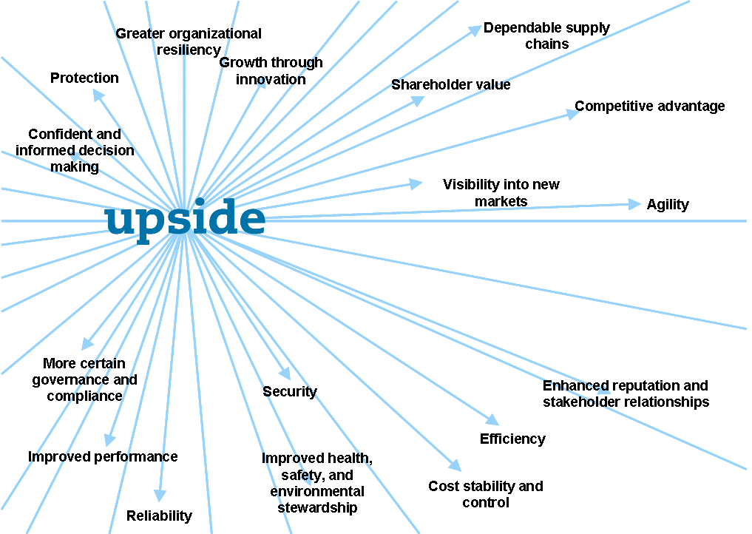

In practice, managing risk can be challenging in that decisions must be made about processes, activities and investments for potential outcomes that may never arise. In addition, changes over time, new processes, shifting responsibilities, and so on, can inherently create new sources of risk. Despite best efforts to manage and control risks, unforeseen events – sometimes out of the control of the organization – can occur without warning. Therefore, when developing risk management programs, it is important to maintain a long-term perspective to, wherever possible: anticipate potential threats and take action to reduce their likelihood of occurring; be continually vigilant to respond effectively to mitigate events that do occur; and maintain adequate response and financial recovery mechanisms to assure the long term viability of the organization.

The following is a simple model of the risk management process. As shown, it is a continuous process aimed ultimately at reducing the overall risk and cost of risk to an organization.

Figure 2: Risk Management Process

Planning

Planning involves developing a plan / strategy (as with any business process, goals, objectives, responsibilities, funding, performance metrics, audit / validation, etc., should be established). Some best practice approaches include:

        - Senior management role models and commitment that recognizes and communicates value of a “risk-safe” culture.
        - Identifying the key stakeholders to be considered or consulted
        - Allocate capital to reflect risks
        - “Four way” communication (top down – bottom up – across business units and functions)
        - Establish a Risk Management policy
        - Integrate business and risk strategies
        - Define roles, responsibilities and expectations

Risk Analysis

Identifying potential risks – Understanding the full spectrum of ‘what can go wrong’ and why?
        - Proactive and systematic process to seek out potential ‘business upsets’ to and throughout the business.
        - Institutionalized risk awareness.

Assessment – Determining how material a risk could be and likely it is to occur
        - Establish boundaries & limits against which to measure risk (risk tolerance).
        - Ongoing, structured risk assessment process.
        - Processes to analyze and trend incidents (loss lessons).

Risk Treatment – A strategy and decision process on which risk treatment method to employ for identified/prioritized risks. This should be a ‘top-down’, fully integrated risk control strategies (planning, design, operations), with responsibilities clearly understood, and may manifest from the following:

        - Exploit - implies that a choice is taken to accept the risk and take further advantage of its potential upside. This normally involves introducing changes in business activities and processes to accommodate informed risk taking.
        - Avoid / Eliminate - Risk taking must be avoided if a risk is deemed to exceed the organization’s risk appetite - either considering human life, from a financial or reputational perspective, or simply because it is not part of the core business. Measures to eliminate undesirable risks may include business changes such as the exit from a particular market, or product substitution.
        - Retain - Risk retention means accepting the risk in-house. Either unfunded as it is (the risk - and a potential loss - is deemed acceptable and / or controls appropriate), or through some form of self-funding mechanism.
        - Reduce / Control - Risk reduction / control is a decision to accept the risk but to introduce additional measures to reduce the potential probability and/or consequence of the exposure. Risk reduction can be through procedural, behavioural or physical measures and improvement of the controls in place, and could entail areas such as:
          - Crisis Management, including Business Continuity Planning
          - Loss Prevention and Control
          - Health and Safety
          - Security
          - Protection of Intellectual Property

        - Transfer - transferring the risk to a third party, options include transfer by contractual arrangements (e.g. to shift / define legal or functional responsibility for risk), the outsourcing of activities, insurance and alternative risk transfer solutions.

Implementation

Implementation of risk treatment strategies requires top down involvement/ senior role models, integration into core business processes and an enabling support environment (including budgets and sufficient resources to implement)

Monitor

A framework of controls and an effective risk review structure to assure risk management information, communication and tools up to date and adapt to changes in the risk profile. This includes having in place:
        - Early ‘warning’ systems
        - Effective information gathering and reporting process up and down
through organization
        - Ongoing review of treatment and control strategies

Risk management is an ongoing process. The organizations risk management framework should be fluid and adaptive to ensure continuous improvement and reflect changing conditions. It begins with planning the risk management infrastructure and resources and continues through the identification and assessment of risks, their treatment and ongoing monitoring. The overall long-term goal is continuous risk improvement.

Risk Management Principles

For risk management to be effective, an organization should at all levels comply with the principles below.

a) Risk management creates and protects value.

Risk management contributes to the demonstrable achievement of objectives and improvement of performance in, for example, human health and safety, security, legal and regulatory compliance, public acceptance, environmental protection, product quality, project management, efficiency in operations, governance and reputation.

b) Risk management is an integral part of all organizational processes.

Risk management is not a stand-alone activity that is separate from the main activities and processes of the organization. Risk management is part of the responsibilities of management and an integral part of all organizational processes, including strategic planning and all project and change management processes.

c) Risk management is part of decision making.

Risk management helps decision makers make informed choices, prioritize actions and distinguish among alternative courses of action.

d) Risk management explicitly addresses uncertainty.

Risk management explicitly takes account of uncertainty, the nature of that uncertainty, and how it can be addressed.

e) Risk management is systematic, structured and timely.

A systematic, timely and structured approach to risk management contributes to efficiency and to consistent, comparable and reliable results.

f) Risk management is based on the best available information.

The inputs to the process of managing risk are based on information sources such as historical data, experience, stakeholder feedback, observation, forecasts and expert judgment. However, decision makers should inform themselves of, and should take into account, any limitations of the data or modeling used or the possibility of divergence among experts.

References

- Winter Salt Management Program – Core Accreditation Standards. Smart About Salt Council. 2017.

- Best Practices – Guidelines for Sustainable Salt Use. Snow & Ice Management Association (SIMA).

- Code of Practice – The Environmental Management of Road Salts. Environment Canada. November 2004.

- Best Management Practices for Salt Use on Private Roads, Parking Lots, and Sidewalks. Environment Canada.

- Syntheses of Best Practices Road Salt Management. Transportation Association of Canada. April 2013.

- “A Low-Salt Diet for Ontario’s Roads and Rivers” Report Summary. Riversides Stewardship Alliance & Sierra Legal Defence Fund. February 2006.

- Optimal Snow and Ice Control of Parking Lots and Sidewalks. A Summary Final Report. University of Waterloo. December 2014.

- Good Practices for Winter Maintenance in Salt Vulnerable Areas. Ontario Good Roads Association & Conservation Ontario. June 2018.

Smart About Salt Council – Example Boxes from Core Accreditation Standards

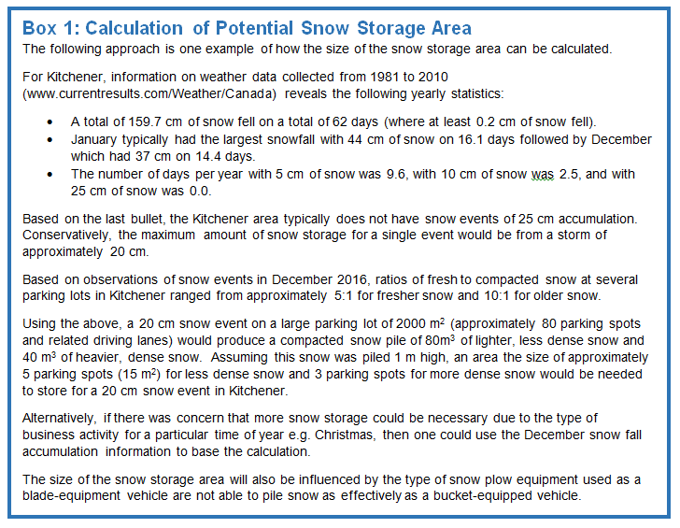
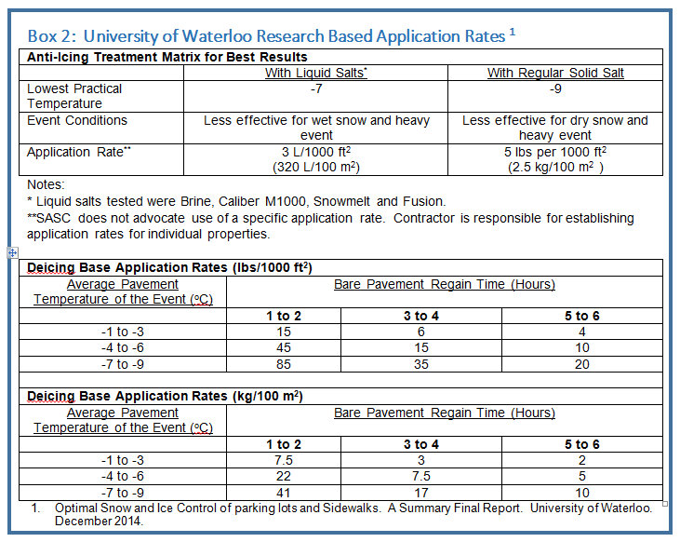
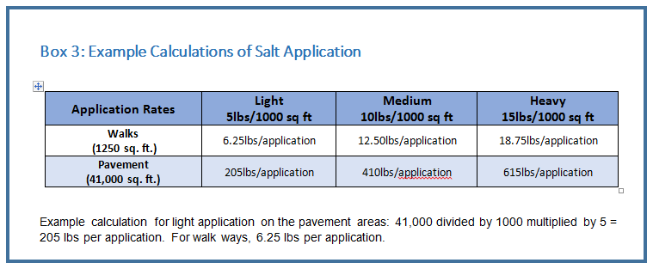
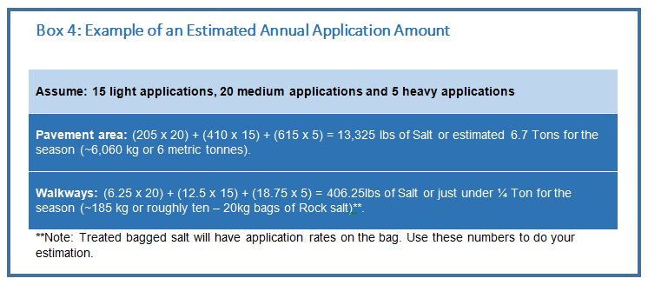
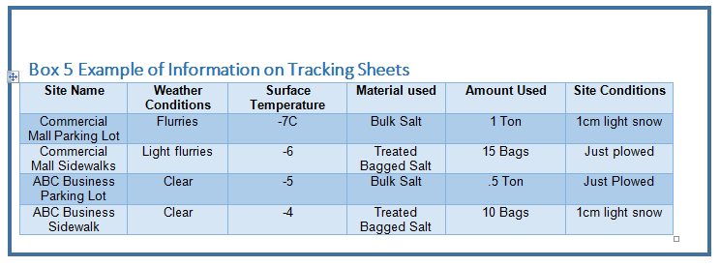
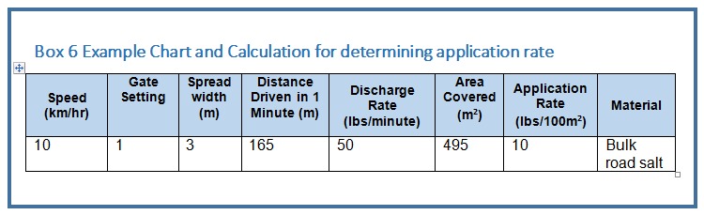

Sample Forms / Checklists

Sample Daily Winter Log Sheet
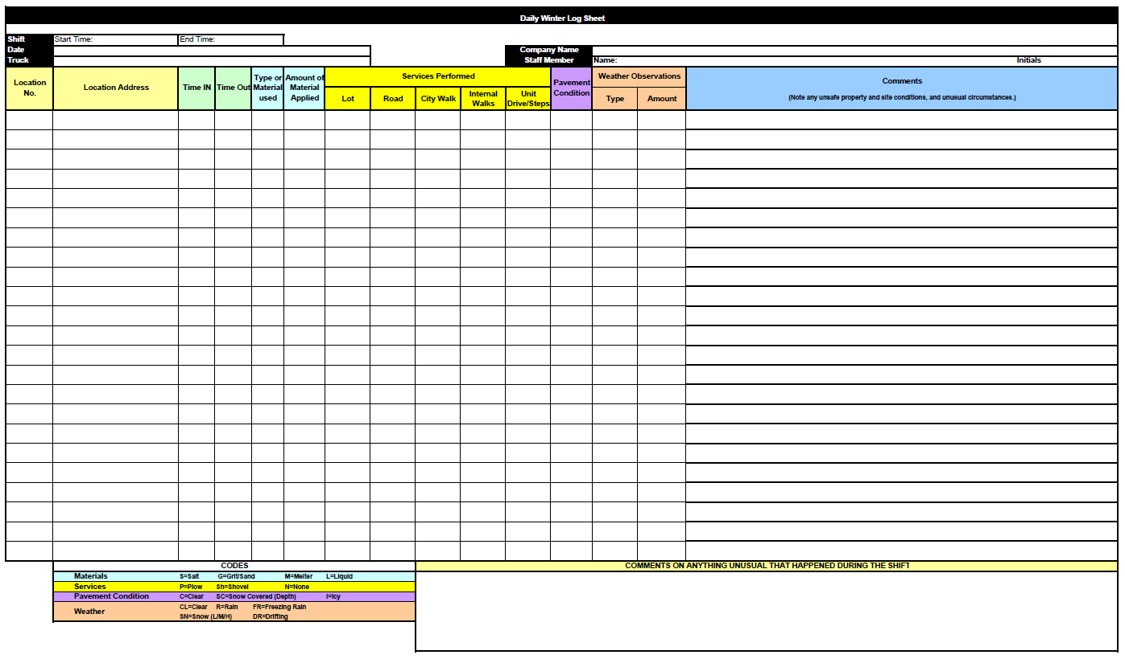

Sample Vehicle Accident Report Form
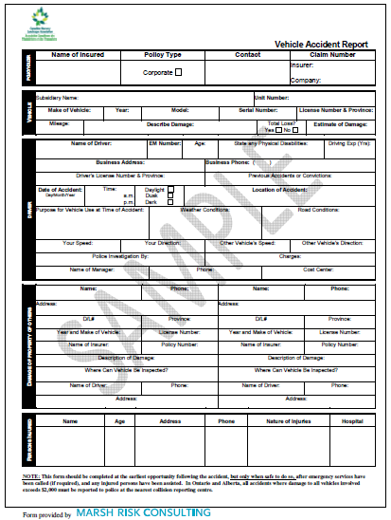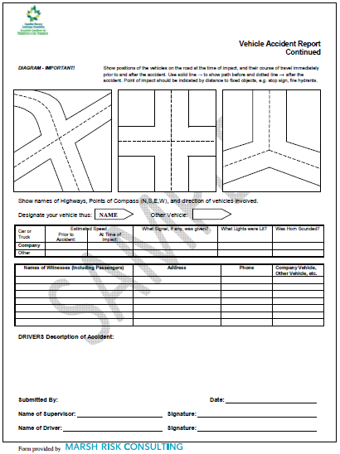

Definitions / Glossary of Terms

AHJ – Authority Having Jurisdiction

Anti-icing: The act of applying a deicer chemical (a liquid or a solid) to a surface before the storm starts in an effort to prevent ice from forming and bonding to the surface or to enhance plowing efforts. Often referred to as ‘pre-treating’ a site, not to be confused with Pre-treating as defined in this glossary.

Calcium Chloride (CaCl2): An exothermic salt.

Calcium Magnesium Acetate (CMA): A biodegradable acetate deicer.

Calibration: Determining a precise measurement of the material output of a given deicer spreading/spraying unit under different settings and vehicle speeds. The goal of calibration is measuring and applying a consistent rate/set of output rates over time.

De-icer: A material to melt snow and ice. Commonly used deicers include sodium chloride, magnesium chloride, calcium chloride, and potassium chloride in either solid or solution (liquid) form. A deicer can be used in the anti-icing or deicing mode of operations. Synonym: Ice Melt.

De-icing: The act of applying a deicer chemical (typically a solid or pre-wet solid) to an accumulation of ice or snow in an effort to melt it and weaken its bond to the surface.

Effective Temperature: The lowest temperature at which it is cost effective or practical to use a deicer.

Ice: The solid form of water. Ice forms only when water is exposed to temperatures below freezing.

Ice Melting: The act of changing the freeze point of water to temperatures below 32°F (0°C) through deicing chemical application. (e.g. Sodium Chloride, Magnesium Chloride, etc.).

Ice Monitoring: A contractually agreed upon service in which one or more people visit a site to monitor for signs of ice accumulation. Synonyms: Ice Watch, Policing, Ice Patrol.

Level of Service (LOS): A description of the expected outcome(s) on a site or set of sites from the completed performance of snow and ice management services. Level of Service typically defines expectations for surface conditions at specific times (completion times) or timeframes, or alternate/additional expectations for events that exceed a defined timeframe and/or a defined amount of accumulation(s).
Synonym: Service Level Agreement (SLA).

Liquid: General term used to describe any deicer chemical in a liquid state. It can be used to pre-treat solid deicers, anti-ice, deice, or pre-wet solid deicers or reapplications.

Magnesium Chloride (MgCl2): An exothermic salt.

Plow: A piece of equipment designed to physically move snow and ice.

Potassium Acetate (KC2 H3 02): A water-soluble crystalline compound composed of Potassium/Carbon, Hydrogen and Oxygen.

Pre-treating: The application of a liquid deicer to a solid deicer product (e.g. rock salt) to further enhance deicer performance. This is not the same as anti-icing.

Pre-wetting: Coating solid materials with liquid to increase effectiveness directly before application. Pre-wetting can be achieved in three main ways:

1. Applied at the spinner as material leaves the spreader.
2. Applied to each load prior to placing it in the spreader.
3. Applied to the entire load of salt prior to putting in the spreader.

Salt Brine: Water saturated or strongly impregnated with salt.

Salt Vulnerable Areas (SVA’s): Environment Canada identifies SVA’s as:
- areas draining into bodies of water
- areas draining into groundwater recharge zones
- areas draining into sources of drinking water
- areas adjacent to salt-sensitive native or agricultural
- vegetation
- areas where road salts can harm wildlife habitat
- areas where road salts can harm local fish or fish habitat

Sand: A combination of granular rock or other material used to provide traction as an abrasive during winter conditions. As it is not soluble in water, it has no melting properties. Synonym: Grit.

Sanding: The application of an abrasive (typically sand) in an attempt to temporarily mitigate slick conditions. Sand does not melt anything but is often used at temperatures when it is too cold for deicers such as Sodium Chloride (NaCl) to work.

Scope of Work (SOW): Defines the service criteria (e.g. snow & ice maintenance, ice management, etc.) and specific areas to be serviced on a site or set of sites. The SOW can include any issues that may impact the execution of service (i.e. poor site drainage, slopes/hills etc.). Synonyms: Statement of Work, Statement of Services. Related term: Level of Service.

Service Area: Specific locations on a site where some portion of work will be performed as a part of the service agreement.

Sidewalk Spreader: A piece of equipment designed to spread deicing materials (solid or liquid) in a sidewalk setting.

Site: The property or collection of contiguous properties where services are to be performed.

Site Map: A visual representation of a site that includes some or all of the following related to snow and ice management: Areas to be serviced/high priority areas, key obstacles, and logistical information such as where snow will be piled, etc.

Snow: Precipitation in the form of ice crystals. It originates in clouds when temperatures are below the freezing point, when water vapor in the atmosphere condenses directly into ice without going through the liquid stage. Once an ice crystal has formed, it absorbs and freezes additional water vapor from the surrounding air, growing into a snow crystal or snow pellet, which then falls to Earth.

Snow Blowing: Moving snow using a belt- or auger-powered unit (i.e. snow blower).

Snow Stacking: The process of creating a large pile of snow for storage or temporary staging.

Snow Storage: Piling or stacking snow in a permanent location until natural melting occurs.

Snow Throwing: Moving snow using a belt- or auger-powered unit (i.e. snow blower). Synonym: Snow Blowing.

Snowplowing: The act of moving or manipulating snow or other winter precipitation using a snowplow.

Sodium Chloride (NaCl): An endothermic salt. Synonym: Rock Salt.

Surface Temperature: The temperature of a ground surface (e.g. black top, concrete, grass) at a specific time and location.

Sweeping: Moving snow or ice accumulation using a broom, either powered by equipment or by hand.

Temperature: A measure of the coldness or warmth at a specific time and location expressed in either Fahrenheit (F) or Celsius (C) degrees.

Thaw and Refreeze: A general phrase related to a series of changes in the physical state of snow or other winter accumulation, in which the accumulation changes from a solid to a liquid then refreezes due to temperature fluctuations. Synonym: Melt and Refreeze.

Sample Scoring / Assessment Scheme

          - Optimized performance (10 points) – Optimized Performance -Full ownership with active program maintenance, testing, exercising and continuous improvement. Risk control system are typically characterized by:
            - Exceptionally high standards which reflect recognized industry best practice to meet the outlined objective
            - Formalized programs, plans, procedures and policies that meet and frequently exceed the expectations outlined in the prescribed objectives.

          - Fully meets objective (9 points) – Embedded - Ownership of the risk control system is established at most or all organizational levels. Risk control systems are typically characterized by :
            - Training and some exercising conducted.
            - Good risk control systems and procedures in place to meet the outlined objectives
            - Formalized programs, plans, and/or procedures and policies that include essential elements as outlined in the prescribed objectives.

          - Mostly meets objective (7 points) – Established – Programs and procedures are communicated throughout the organization. Risk control systems are typically characterized by:
            - Ongoing orientation.
            - Risk control systems & procedures in place however, some elements need improvement to achieve intended objectives.
            - Formalized programs, plans, and/or procedures and policies that include most, but not all, essential elements as outlined in the prescribed objectives.

          - Partially meets objective (4 points) – Formalized – Programs and procedures are established. Full familiarity is uncertain. Risk control systems are typically characterized by:
            - Some risk control elements being place however, significant improvements are needed to achieve the intended objectives.
            - A formalized plan is in place, but is not consistently implemented and/or followed.
            - Unwritten procedures that generally meet the objectives and are consistently followed.

          - Minimal controls in place (2 points) – Undeveloped – Ad hoc actions with little or no systematic procedures. Risk control systems are typically characterized by:
            - Minimal risk control systems in place to address the objectives
            - Some programs, plans, procedures and/or policies may be in place but do not meet the performance objectives
            - Unwritten procedures only partly meeting the objectives or that are not consistently followed or implemented.

          - No controls in place (0 points) – Unaware – No awareness or recognition of the risk issue or need for associated controls. Typically characterized by:
            - No risk control systems in place to address the objectives

          - Not applicable – This element was deemed as not applicable for this location

          - Not reviewed – Due to special circumstances, this item could not be reviewed & evaluated.

        - ‘Notes’ – Additional comments and references as relevant.

Marsh Canada Limited
120 Bremner Boulevard, Suite 800
Toronto, Ontario M5J 0A8
+1 416 868 2600
This document and any recommendations, analysis, or advice provided by Marsh (collectively, the “Marsh Analysis”) are intended solely for the use of CNLA and associated provincial member companies. This document contains proprietary, confidential information of Marsh and may not be shared with any third party, including other insurance producers, without Marsh’s prior written consent. Any statements concerning actuarial, tax, accounting, or legal matters are based solely on our experience as insurance brokers and risk consultants and are not to be relied upon as actuarial, accounting, tax, or legal advice, for which you should consult your own professional advisors. Any modelling, analytics, or projections are subject to inherent uncertainty, and the Marsh Analysis could be materially affected if any underlying assumptions, conditions, information, or factors are inaccurate or incomplete or should change. The information contained herein is based on sources we believe reliable, but we make no representation or warranty as to its accuracy. Except as may be set forth in an agreement between you and Marsh, Marsh shall have no obligation to update the Marsh Analysis and shall have no liability to you or any other party with regard to the Marsh Analysis or to any services provided by a third party to you or Marsh. Marsh makes no representation or warranty concerning the application of policy wordings or the financial condition or solvency of insurers or reinsurers. Marsh makes no assurances regarding the availability, cost, or terms of insurance coverage.

